**The Future of Business Models: How Ethereum Blockchain with Smart Contract Wallets and Decentralized Storage are Revolutionizing the Business Landscape**

Annur Hangga Prihadi

[prihadihangga@gmail.com](mailto:prihadihangga@gmail.com)

https://hanggaprihadi.github.io/

**Abstract.** Blockchain technology is viewed as a groundbreaking option for prioritizing peer-to-peer systems and decentralized data for organizational data. It enables the updating of decentralized monetary systems, such as Bitcoin and Ethereum Smart Contracts. By offering easier record auditability, blockchain can foster greater trust among supply chain actors. In addition, the technology can aid in tracking goods in the supply chain from one entity to another. The MVP is developing Tx ID supply chain processes to build business solutions in the supply chain transparency process. The research leverages Ethereum, Safe smart contract wallet, and Arweave Decentralized Storage to create a prototype blockchain system that generates Tx ID for transparency in ongoing supply chain business activities and proven purchase order receipt. Consumers can easily access transparent transaction data due to the blockchain's ability to record data. By reducing fraudulent activities and enhancing efficiency, blockchain technology can offer an effective solution to creating a more transparent and secure supply chain for all parties involved. All entities in the supply chain must agree to the implementation to ensure the effectiveness of the system.

1. **Introduction**

Blockchain technology is widely regarded as a revolutionary option in the development of technologies that prioritize peer-to-peer systems, decentralized data for organizational data. Blockchain enables the updating of decentralized monetary systems such as Bitcoin, Ethereum Smart Contracts, Binance Smart Chain, and other resources that can be managed online. Blockchain technology enables different entities to exchange data and make transactions within minutes without the intervention or verification of third parties such as banks when processing customer transactions. This can be achieved through a shared data framework that uses computer algorithms to make real-time updates. Blockchain technology holds great promise for revolutionizing organizational domains such as the supply chain in conducting their business activities.

Currently, the supply chain process is highly structured, global, and interconnected. Data and product documentation regarding safety, sustainability, sourcing, and other attributes are typically recorded and stored on paper or private databases, and can only be accessed by trusted third-party authorities. This situation makes data access expensive, time-consuming, prone to manipulation, corruption, and errors, posing a risk of loss in the business process, especially in the financial field. Many industries work with governments and independent watchdogs to enable better information transparency and build trust among stakeholders in the supply chain process.

Despite the ongoing trend of digitalization in the economy, the supply chain process is still one of the least digitized processes. Blockchain technology has the potential to impact this situation in many ways, as it offers something in the form of immutable data in transaction records, which can be accessed by all entities. Therefore, blockchain can be an instrument to create more trust among supply chain actors due to easier record auditability. Furthermore, blockchain technology can facilitate tracking and visibility of goods in the supply chain, by tracking goods from one entity to another.

The aim of this research is to create a blockchain system that generates a TX ID for the supply chain process, making business activities more transparent, ensuring smooth confirmation in blockchain implementation, and storing receipt data in decentralized storage. The limitations of this research include the use of the Ethereum network for the blockchain platform, the Safe smart contract wallet for confirmation and ease of interaction with the blockchain, and the Arweave network for decentralized storage.

1. **Ethereum Architecture**

The fundamental concept of the Ethereum architecture revolves around the execution of smart contracts that are designed to cater to the specific requirements of the blockchain industry. The architecture is composed of smart contracts that interconnect various technologies and enable the Ethereum ecosystem to function smoothly by creating blocks that contain user transaction data. A mining node is a computer that monitors transactions that occur on the Ethereum blockchain network, and each block contains pertinent information.

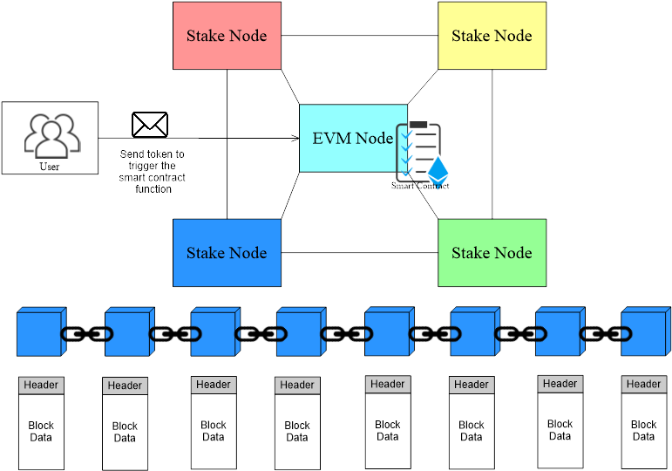

1. **Safe Smart Contract Wallet Architecture**

Many cryptocurrency users, including those who own Crypto, are accustomed to using a single key wallet called an externally owned account (EOA), which includes popular options like MetaMask, Trustwallet, and Exodus. These accounts are secured with a 12-word seed phrase that can be converted into a private key for the user. If the private key is ever compromised, the funds can be stolen. This is where Multisig comes into play. Safe is a smart contract wallet that operates on multiple blockchains and requires approval from a minimum number of individuals before a transaction can occur (M-of-N). For example, if a business has three main stakeholders, the wallet can be configured to require approval from three out of four (3/4) or all four people before a transaction is executed. This ensures that no single person has the ability to compromise the funds.

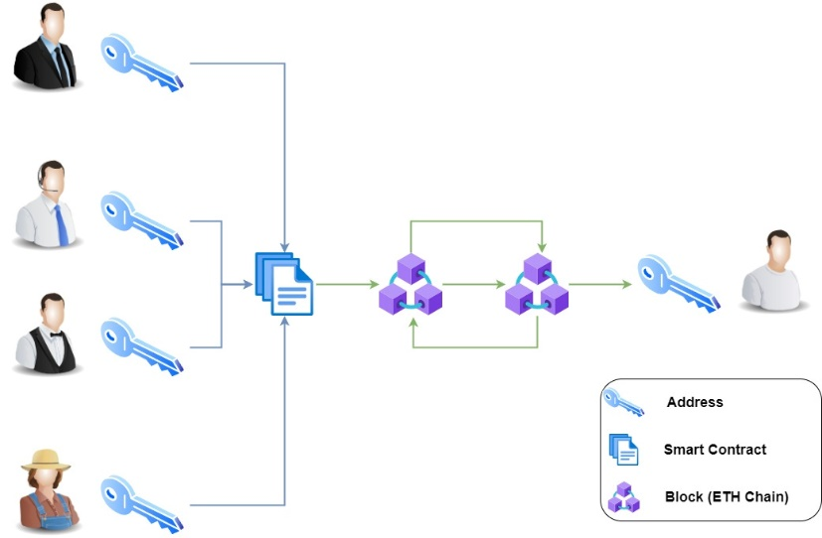

1. **Arweave Architecture**

Arweave is a protocol that makes permanent data storage possible. It is designed in such a way that anyone can keep their data forever with a single one-time payment. Arweave is a different kind of storage system, which secures data using sustainable and perpetual endowments. It works like a collectively owned hard drive that never forgets, allowing us to preserve essential information and records indefinitely, preventing any possible alteration of history. Arweave is built on the first truly scalable cryptocurrency, and its innovative 'blockweave' technology ensures efficient, self-organizing data storage that guarantees data will be available for many years, decades, and even centuries to come, without being altered accidentally or intentionally.

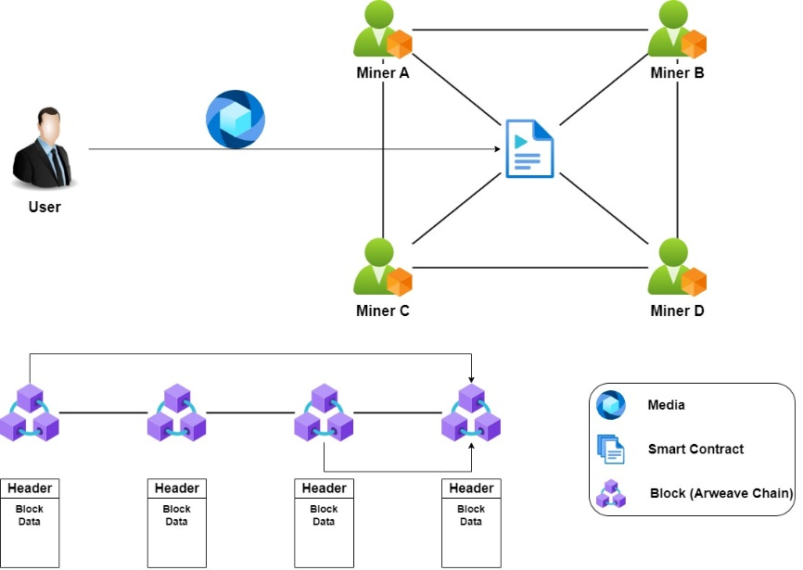

1. **Cloud Architecture**

We can utilize the GCP service called Django Packaged by Bitnami in Deployment Manager to create an online CMS site. This service is directly integrated with Compute Engine and VPC, which makes the process more efficient.

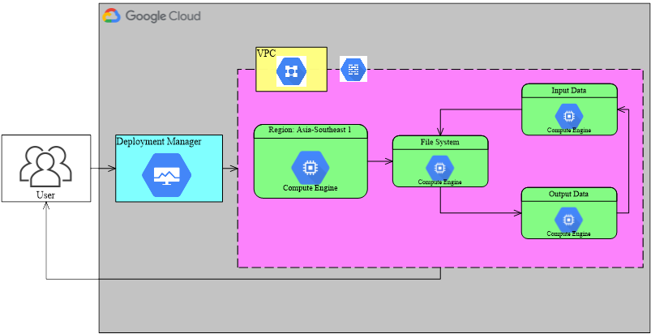

1. **Smart Contract Modification**

To create an Ethereum address, the user must first install the MetaMask application and create an Ethereum account. It is important to note that deploying a smart contract on the Ethereum network requires a fee. Therefore, users need to have Ethereum (ETH) in their accounts, which can be obtained through participating in an airdrop or purchasing from an exchange.

Once the user has Ethereum (ETH), they can proceed to open the Remix Ethereum IDE using the dedicated development environment link (remix.ethereum.org). The user can create and edit smart contracts based on their business needs. For example, they can refer to this link (https://github.com/hanggaa/Example/blob/main/hangga.sol) to learn about smart contracts.

Smart contracts work by creating a new token running on the Ethereum network, allowing entities to send tokens between each other while writing data on the blockchain. After creating or modifying a smart contract, the next step is to match it with the compiler. It is important to ensure that the Solidity version matches, as a compilation process failure may occur if it does not.

Once the smart contract is successfully compiled, the user can run it on the EVM node or on the Ethereum network. The deployment process involves selecting Injected Web3 (MetaMask) as the deploy payment method.

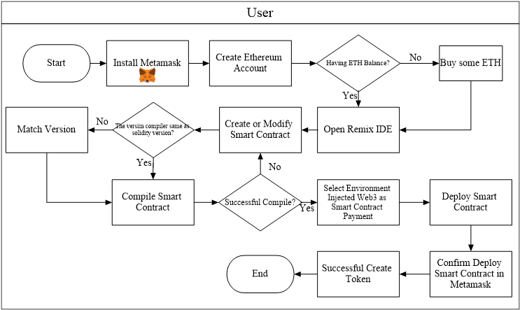

1. **Supply Chain Business Processes Using Blockchain**

The restaurant creates a purchase order for food ingredients to be sent to the restaurant from the retailer. After the food ingredients are received, the restaurant creates a food label in the form of a QR code that can be scanned by customers to track the supply chain process and the food ingredients used in the food.

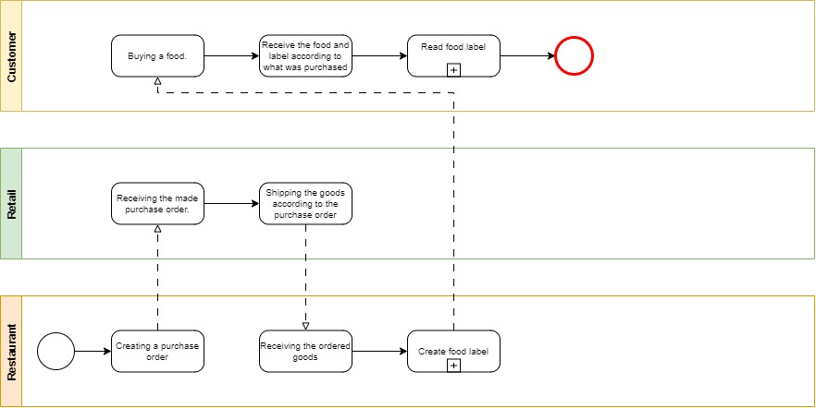

In the process of creating food labels, the restaurant inputs the shopping receipt into the Arweave chain and inputs data into the Ethereum chain, then inputs the food ingredients and blockchain transaction receipts into the CMS system before generating a QR code for users to scan and view information about the food they consume.

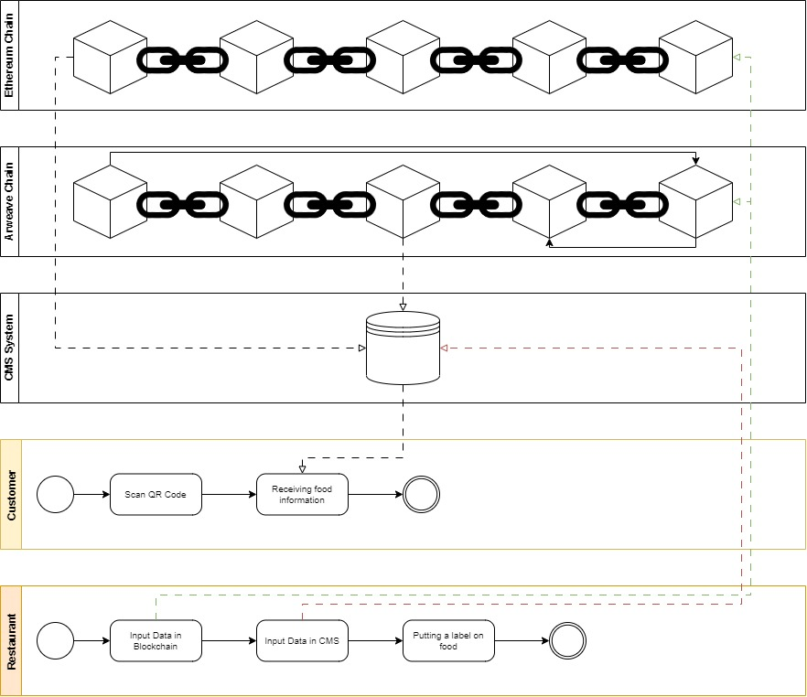

1. **Logistics and Transport Process**

The supply chain process starts with the restaurant requesting a purchase order from the storehouse. The storehouse then validates the order and sends a shipping report to the warehouse. In the warehouse, there is an allocation and load planning process for the items before they are picked up by the courier and delivered to the restaurant. Additionally, the restaurant creates a transaction ID on Ethereum by sending tokens to a special entity and creates a transaction ID on Arweave by sending media on the network.

If there are any issues with the order at the retail stage, a Proof of Delivery (POD) process is initiated. Both the retail and warehouse parties must fill out a form according to the specific cases, such as damaged, lost, exchanged goods, missed products, or other scenarios.

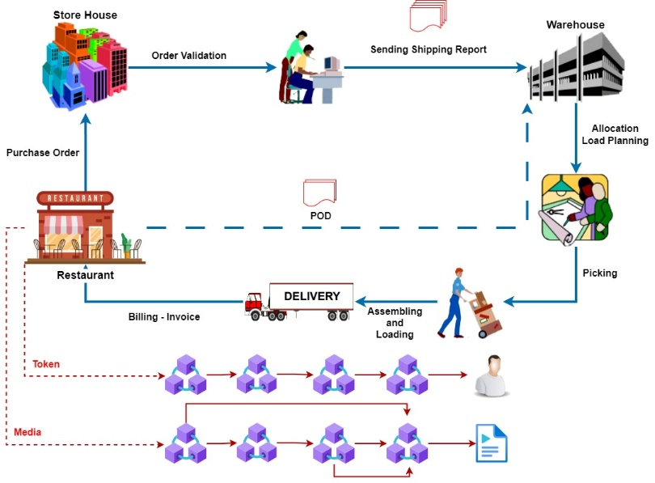

1. **QR Code**

The user copies the website link stored in the QR Code, pastes it into a system that converts it into a new QR Code, and then prints it out to be used as the product label.

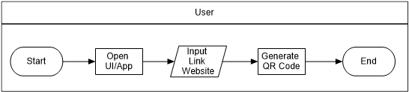

1. **Print QR Code**

The QR code serves as a link that enables customers to trace the supply chain process of the raw materials used in the restaurant. Customers can scan the code using their mobile devices and access the predetermined link, which displays the entire process from sourcing to processing. An example of a QR code is shown in the picture below.



1. **Website Display**

Once the customer scans the QR code, a web page will appear with information that has been entered into the CMS. This information includes photos of food ingredients, blockchain data, descriptions of goods, and supplier maps. Customers can view the blockchain data by selecting the "Tx ID" button to confirm whether the Ethereum addresses of the supply chain actors are working together. They can also view the proof of ingredient supply chain by selecting the "The Prove" button.

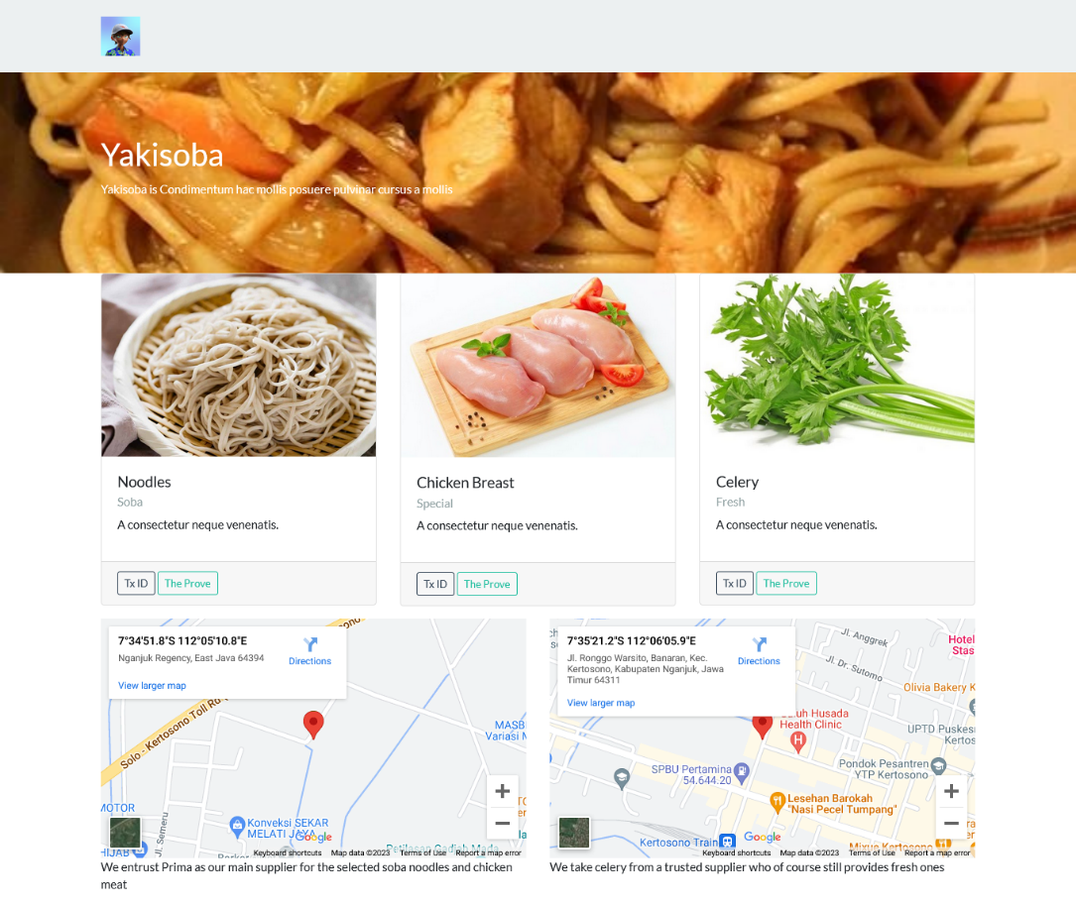

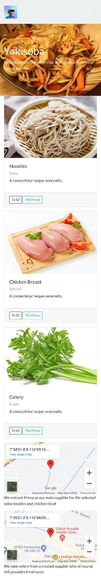

1. **Conclusion**

The research has demonstrated that the design of the system can ensure transparency in the supply chain process by leveraging blockchain technology. Smart Contracts enable entities to interact with the blockchain, making it easier for each of them to access transparent and immutable data. As a suggestion, it would be beneficial for all entities involved to reach a mutual agreement in implementing this supply chain system, which can ultimately lead to increased transparency and trust among end consumers.

**References**

1. J.-G. Song, M. Sung-Jun and J. Ju-Wook, "A Scalable Implementation of Anonymous Voting over Ethereum Blockchain," Sensors, vol. 21, no. 3958, pp. 1-19, 2021.
2. A. K. Shrestha, J. Vassileva and R. Deters, "A Blockchain Platform for User Data Sharing Ensuring User Control and Incentives," vol. 3, pp. 1-22, 2020.
3. G. A. Motta, B. Tekinerdogan and N. Athanasiadis, "Blockchain Application in the Agri-Food Domain: The First Wave," vol. 3, pp. 1-13, 2020.
4. A. Maghfirah and Hara, "Blockchain in Food and Agriculture Supply Chain: Use-Case of Blockchain in Indonesia," International Journal of Food and Beverage Manufacturing and Business Models, vol. 4, no. 2, pp. 53-66, 2019.
5. H.-J. Kim and e. al, "Smart Decentralization of Personal Health Records with Physician Apps and Helper Agents on Blockchain: Platform Design and Implementation Study," JMIR Medical Informatics, vol. 9, no. 6, pp. 1- 14, 2021.
6. I. T. Javed, F. Alharbi, B. Bellaj, T. Margaria, N. Crespi and K. Naseer, "Health-ID: A Blockchain-Based Decentralized Identity," Healtcare, vol. 9, no. 712, pp. 1-21, 2021.
7. A. Hasselgren, Jens-Andreas, K. Kralevska, D. Gligoroski and A. Faxvaag, "Blockchain for Increased Trust in Virtual Health Care:," Journal Medical Internet Research, vol. 23, no. 7, pp. 1-15, 2021.
8. G. Gursoy, C. M.Brannon and M. Gerstein, "Using Ethereum blockchain to store and query pharmacogenomics data via smart contracts," BMC Medical Genomics, vol. 13, no. 74, pp. 1-11, 2020.
9. M. S. Al-Rakhami and M. Al-Mashari, "A Blockchain-Based Trust Model for the Internet of Things Supply Chain Management," sensors, vol. 21, no. 1759, pp. 1-15, 2021.
10. M. S. Ali, M. Vecchio, G. D. Putra and S. S. Kanhere, "A Decentralized Peer-to-Peer Remote Health Monitoring System," Sensors, vol. 20, no. 1656, pp. 1-18, 2020.